JSP and Servlets

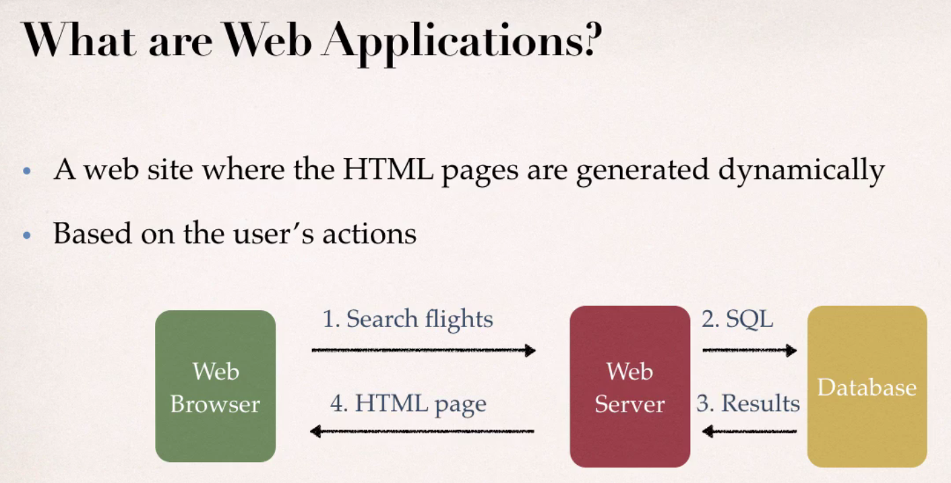

What are JSPs and Servlets ?

- Java code that runs on the web server
- Read user's actions, normally from HTML form
- Performs the work – talking to a database or webserver, etc
- Returns an HTML page that is generated dynamically on the fly.

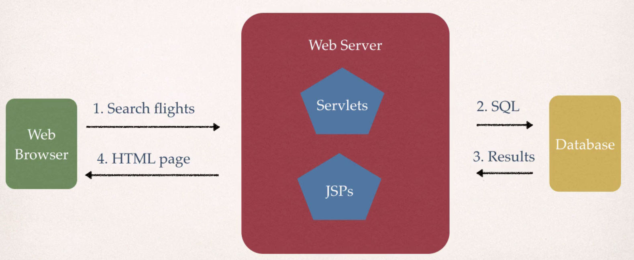

JSPs and Servlets are key components of the Java EE.
Popular MVC frameworks are actually built on top of JSP and Servlets.
- Spring MVC
- JSF
- Struts

Servlets 3.1 and JSP 2.3

To Build JSP applications, you need the following :
- Java Application Server – Glassfish, Jboss, Weblogic, Tomcat, etc.
- Java IDE – Eclipse IDE

Installing Tomcat server

Visit website : http://tomcat.apache.org

Stick with Tomcat 8.0.x version for this learning.

Install 32-bit/64-bit Windows Service Installer

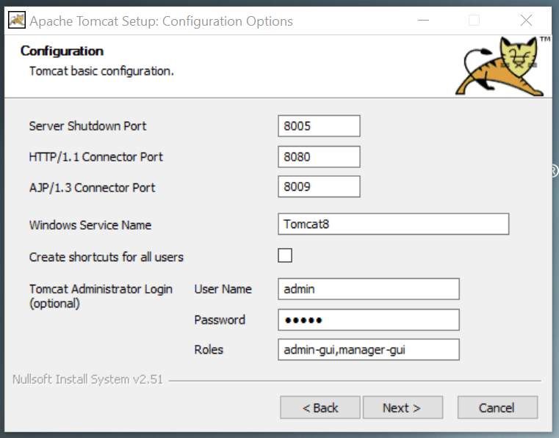
Choose user name : admin
password: admin

Leave all those port numbers as default like that.

Verify the Tomcat installation :
http://locahost:8080/

If everythig is correctly installed, you should see this :

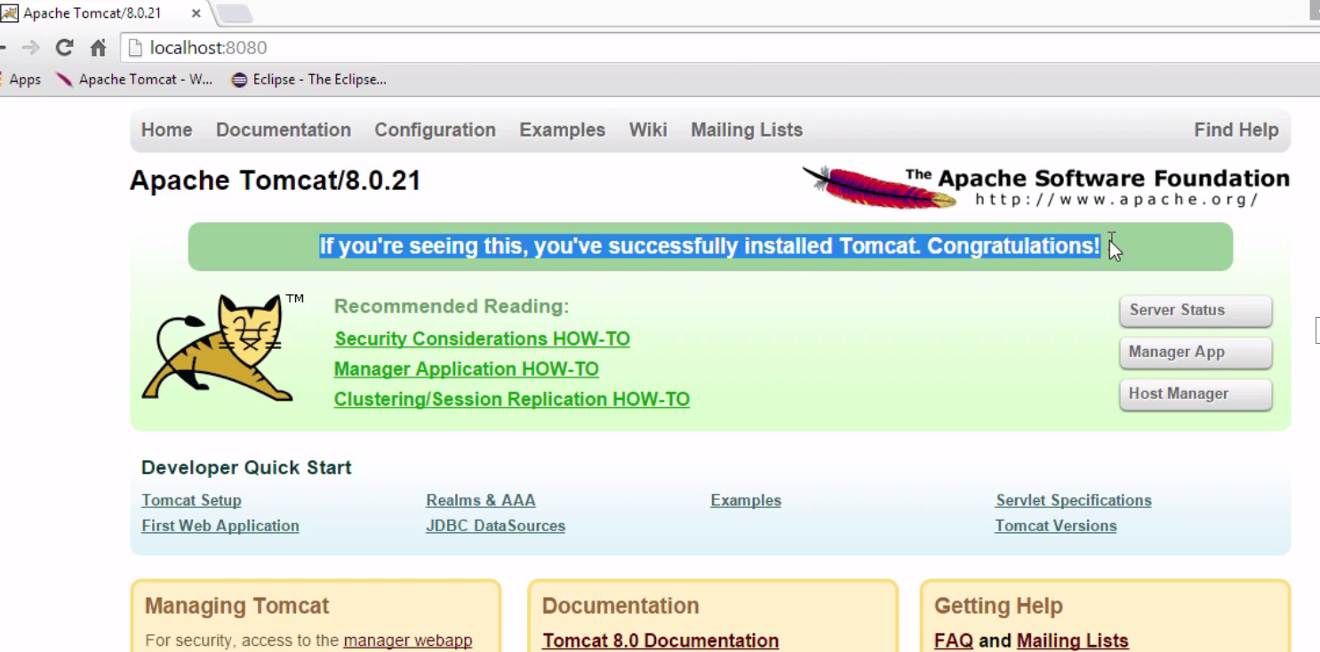
You can also configure Tomcat :
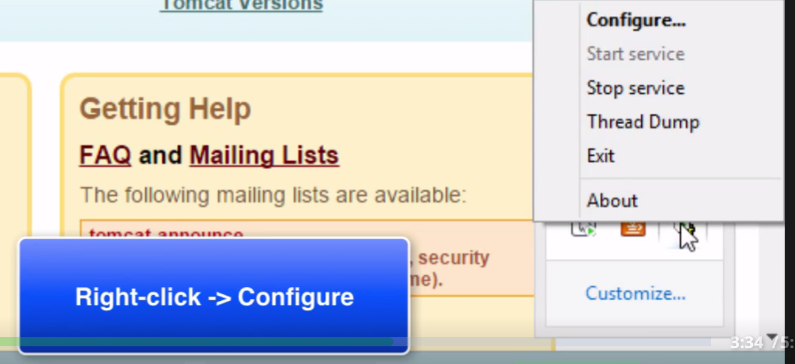
Stop the Tomcat service which is running. We are going to hookup Tomcat through Eclipse to run them together.

Install Eclipse IDE for Java EE for our learning. Www.eclipse.org/downloads/

Connecting Eclipse to Tomcat :

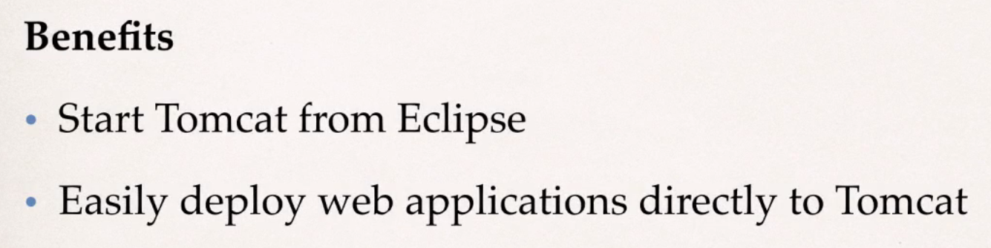

Step 1: Open Eclipse IDE and move down to bottom and click on 'Servers' tab.
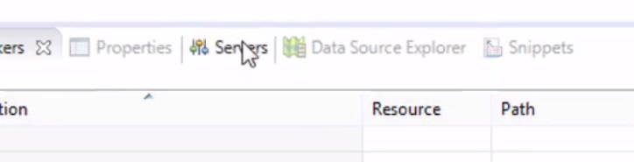

You should see something like this : At this point, we don't have any servers attached to Eclipse.

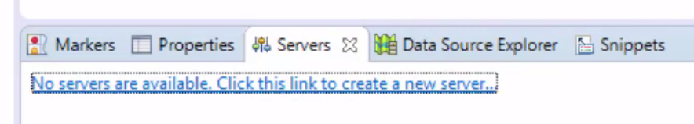

Click on the link and you should see something like this :

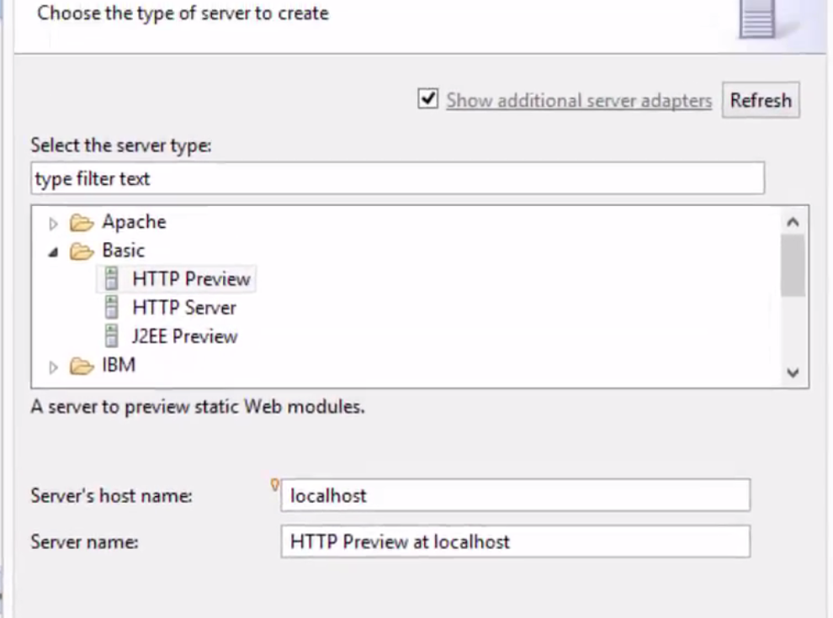
Choose Apache --> Tomcat v8.0 Server
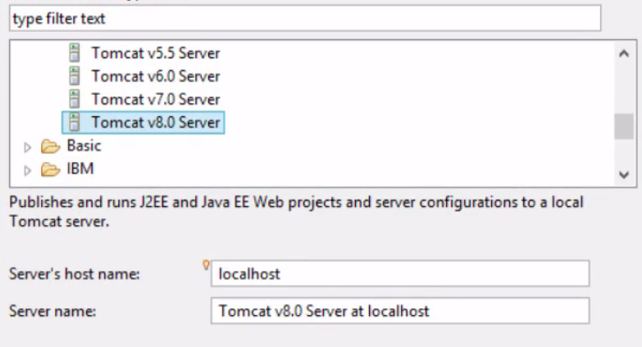

Click Next

On this screen, we need to tell Eclipse, where Apache Tomcat installation directory is :

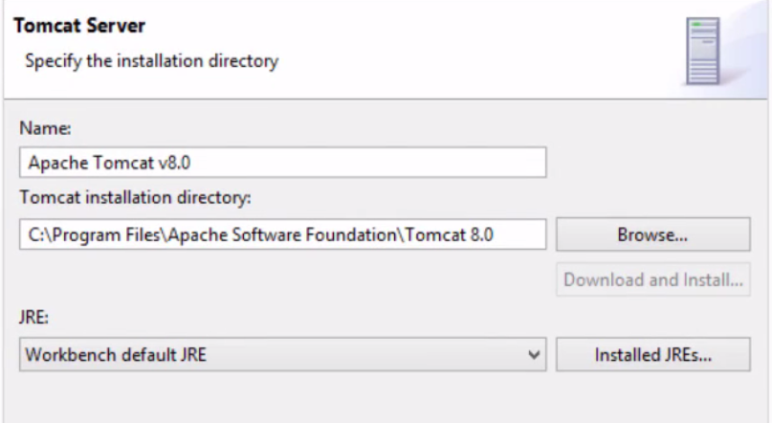

then, click Finish.

This will associate Tomcat with Eclipse IDE.

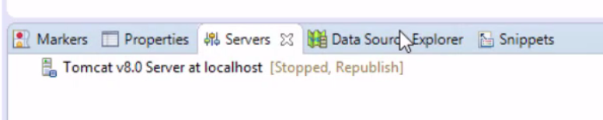

At this point, the server is not running. That's okay.

What is JSP File ?

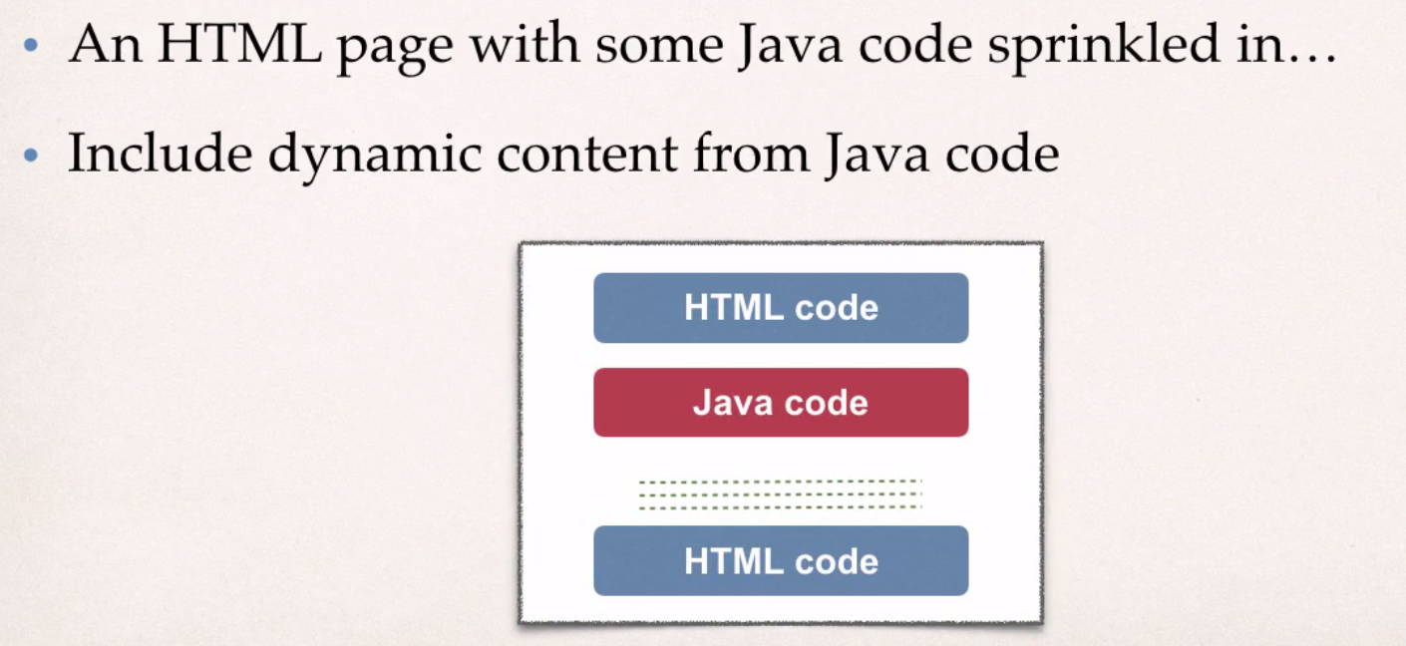

Where is the JSP code processed ?

- JSP is processed on the server
- Results of Java code included in the HTML returned to browser.

Where to place JSP file ?
- The JSP file goes in your WebContent folder
- Must have .jsp extension.
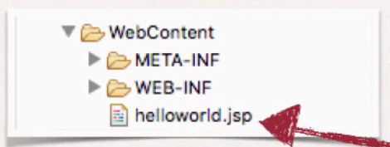

JSP HelloWorld!!

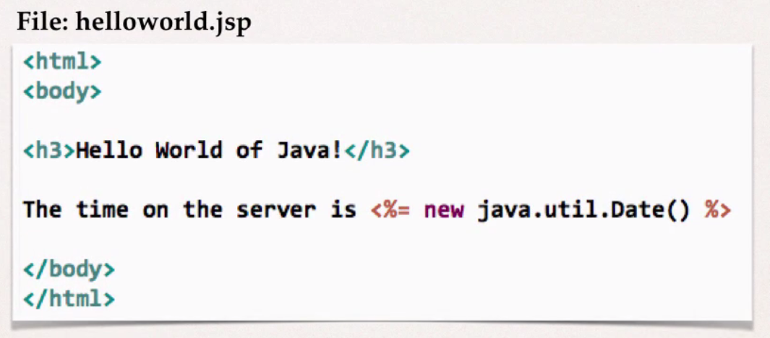
JSP file is nothing but an HTML file, with a bit of Java code embedded in.

<% = new java.util.Date( ) %> ----> this is JSP expression.

Switch over to Eclise IDE and Create a New Web project : File -> New -> Dynamic Web Project

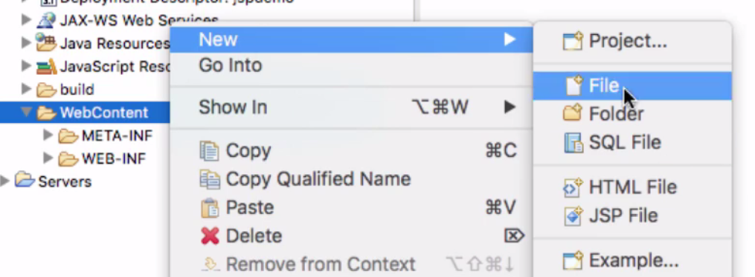

Give the file name : helloworld.jsp

<%@ page language="java" contentType="text/html; charset=ISO-8859-1"
pageEncoding="ISO-8859-1"%>
<!DOCTYPE html PUBLIC "-//W3C//DTD HTML 4.01 Transitional//EN" "http://www.w3.org/TR/html4/loose.dtd">
<html>
<head>
<meta http-equiv="Content-Type" content="text/html; charset=ISO-8859-1">
<title>JSP HelloWorld Example</title>
</head>
<body>
<h3>Hello World of JSP!</h3>
The time on the server is <%= new java.util.Date() %>
</body>
</html>

Running the file on server :

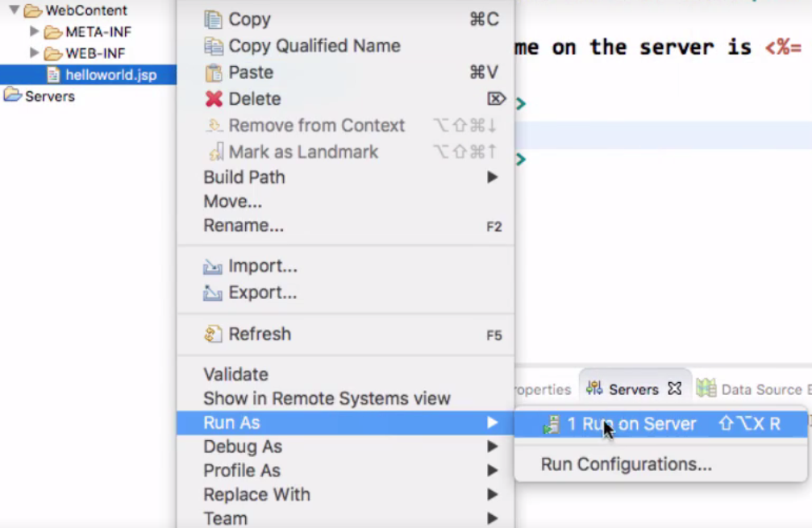

When you run it, you see output like this :

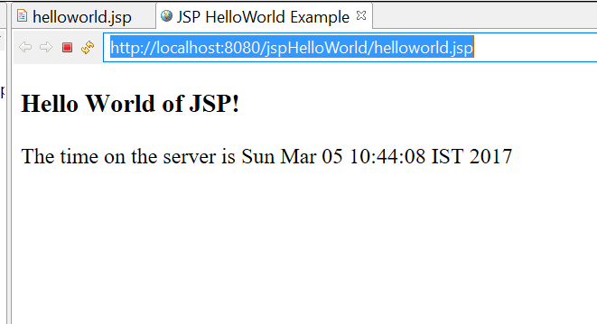

JSP Scripting Elements :

In JSP, there are different types of scripting elements.

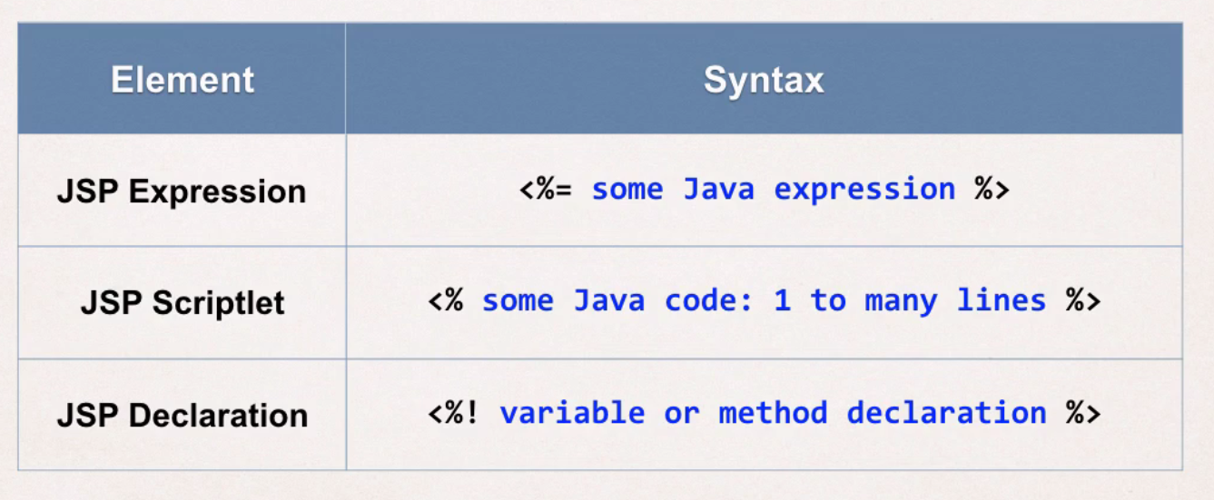

JSP Expressions

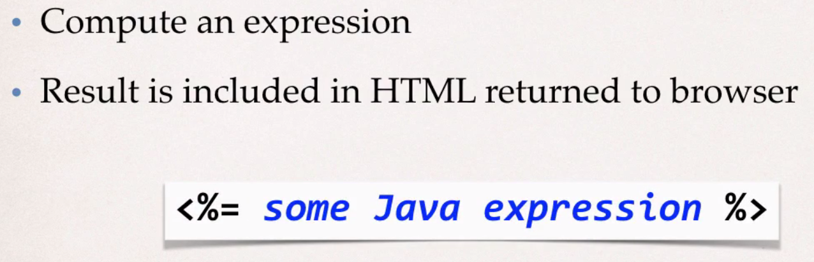
Example from our JSP HelloWorld program : (check above )
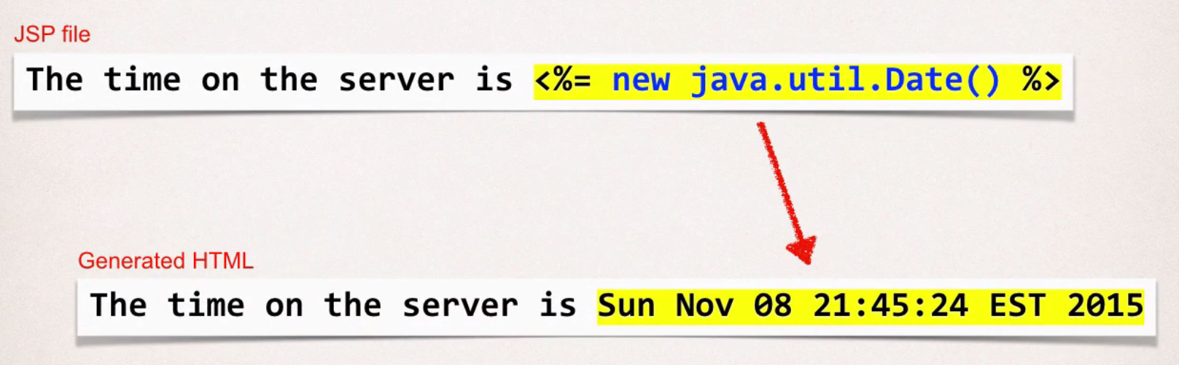
More Examples :
<html>
<body>
Converting a string to uppercase: <%= new String("Hello World").toUpperCase() %>

<br/><br/>

25 multiplied by 4 equals <%= 25*4 %>

<br/><br/>

Is 75 less than 69? <%= 75 < 69 %>

</body>

</html>

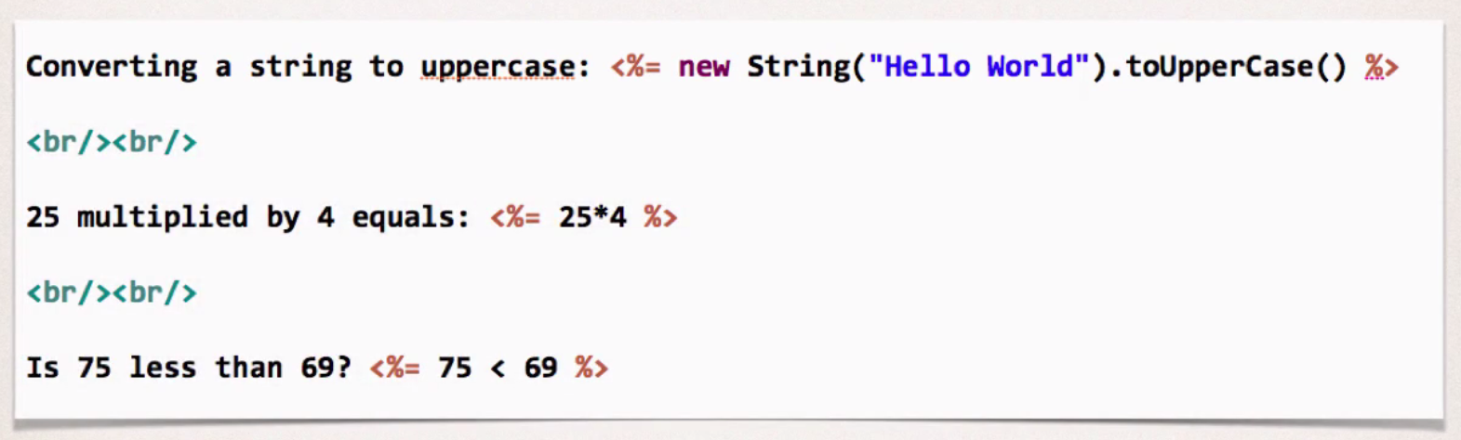
JSP Scriptlets

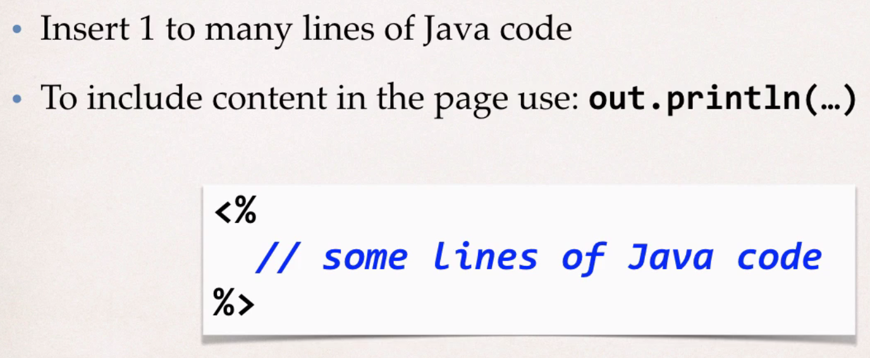
Example :
To render something to the browser, we can use out.println( ) method.

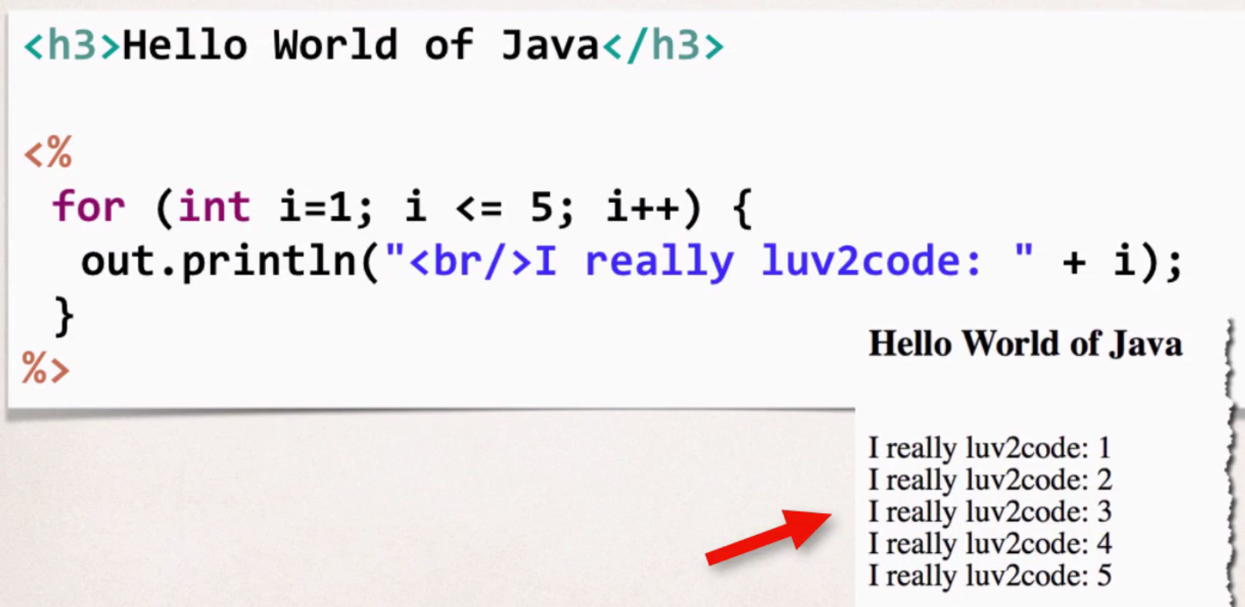
Recommendations / Best Practices
- Minimize the amount of scriptlet code in a JSP.
- Avoid dumping thousands of lines of code in a JSP.
- Refactor this into a separate Java class...make use of MVC pattern.

JSP Declarations

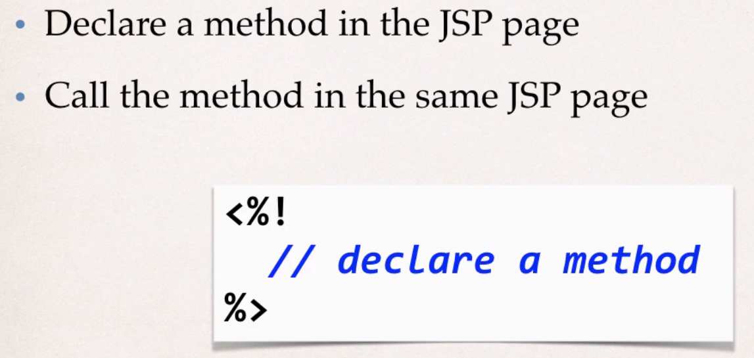

Example :
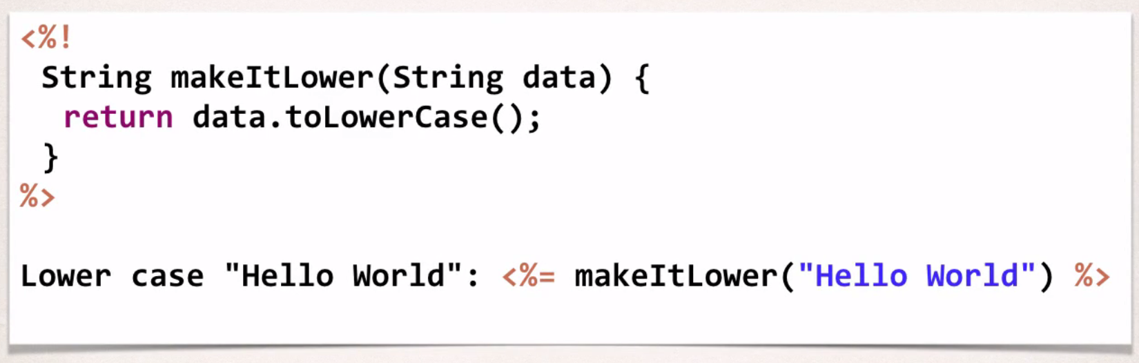

Calling a Java class from JSP

In some of the recommendations above, we are telling to refactor the code into a separate Java class. If we do so, then how you do call Java class from JSP??

Java class will have all of our business logic and JSP will simply make a call to get the results and have some html code to render the data to the user in browser.

Steps:
1. Create a Java class
2. Call java class from JSP

We are creating a Java class in a package. Name of the class is 'FunUtils'.
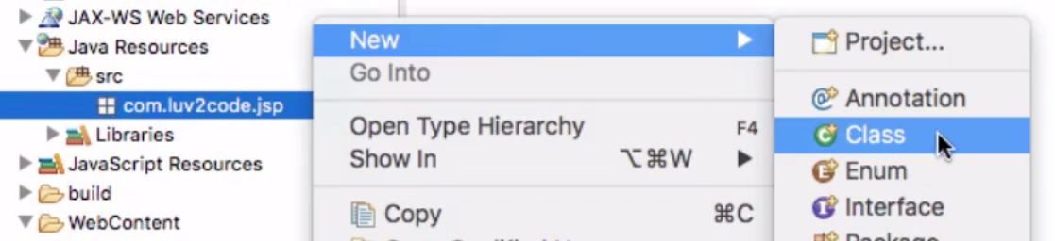

The code of the Java class is like this :
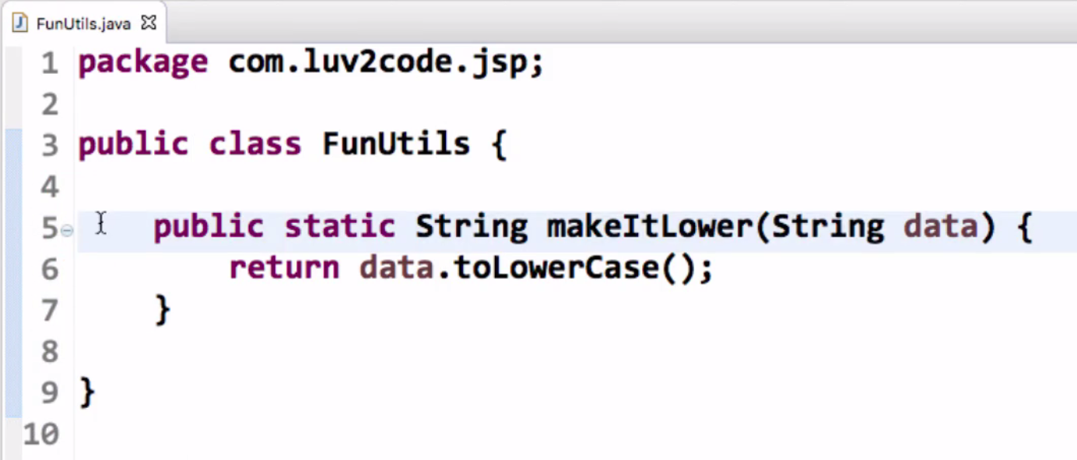
After that, we now create JSP file that make use of this Class. It calls the method in the class.
We use
<%@ page import = "<class name>" %> ---> to import classes in JSP file.

You can use wild cards, comma separated list of imports, etc.
<%@ page import = "com.rdayala.jsp.*, java.util.Date, java.util.*" %>

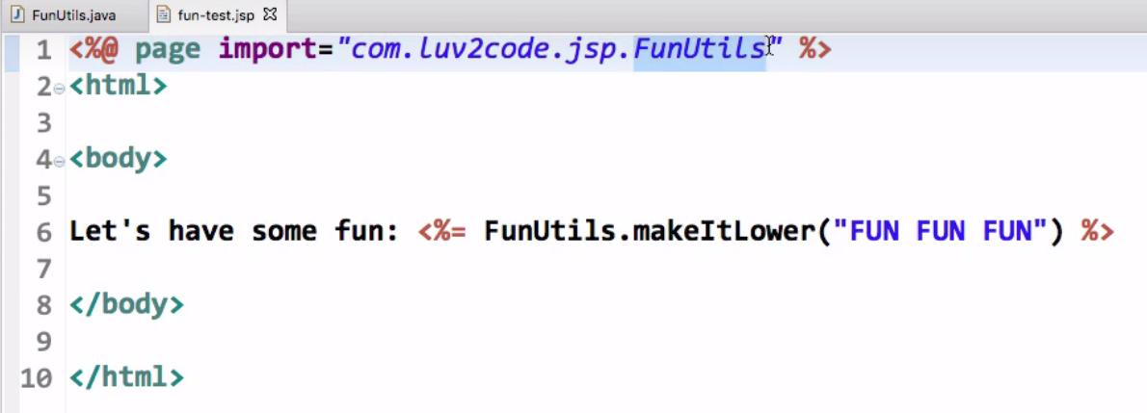

JSP Built-in Server objects

JSP also has some of built-in server objects, which we can use them directly in our JSP page. Few of them are :
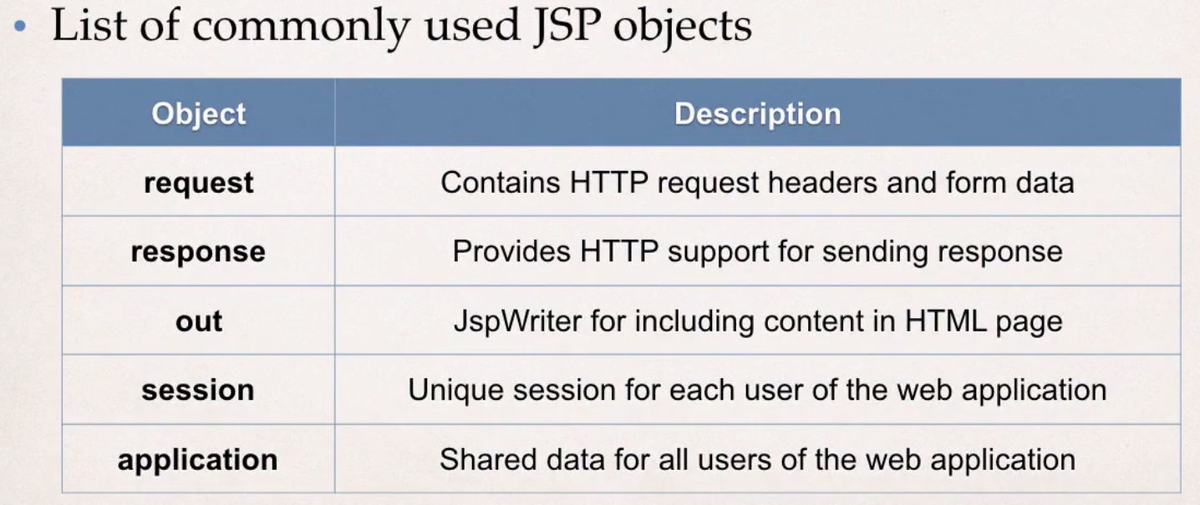
Example:
<html>

<body>

<h3>JSP Built-In Objects</h3>

<!-- this will give the browser that we are using to run this file and
also the operating system -->
Request user agent: <%= request.getHeader("User-Agent") %>

<br/><br/>

Request language: <%= request.getLocale() %>

</body>

</html>

Including other JSP files inside a JSP file

The common usecase for including files in JSP file is for including standard headers and footers for a HTML page.

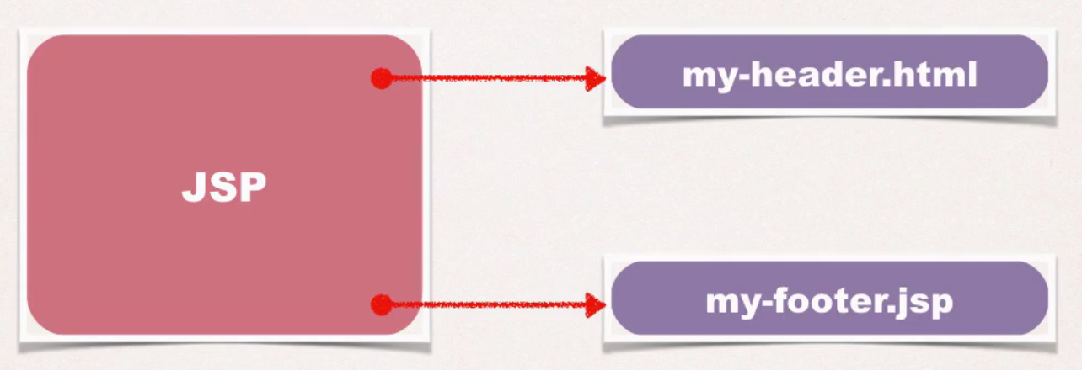
Say for example, you're building a website and you want to have the same header and footer information displayed on every page.

You can simply create the header and footer in separate files and include them in your JSP files.

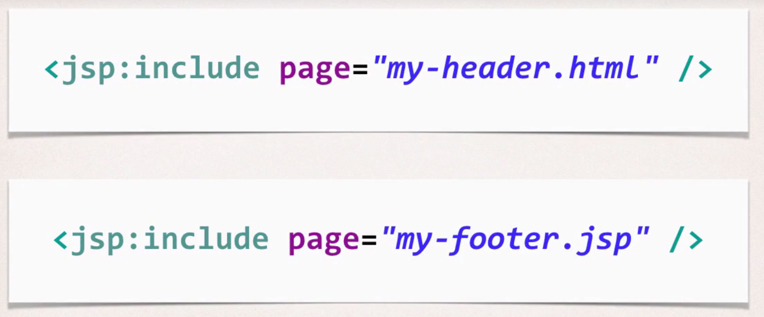

Example:
my-header.html
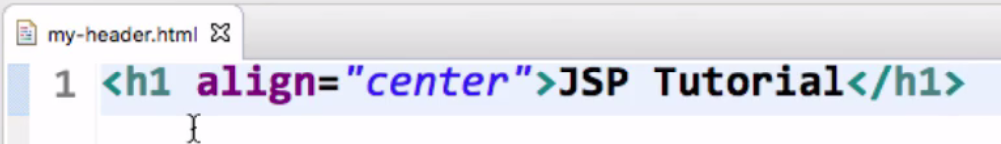

my-footer.jsp
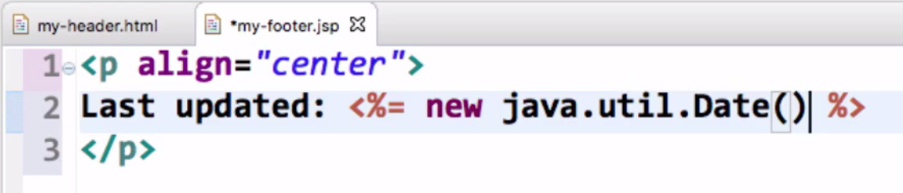
Webpage to include header and footer
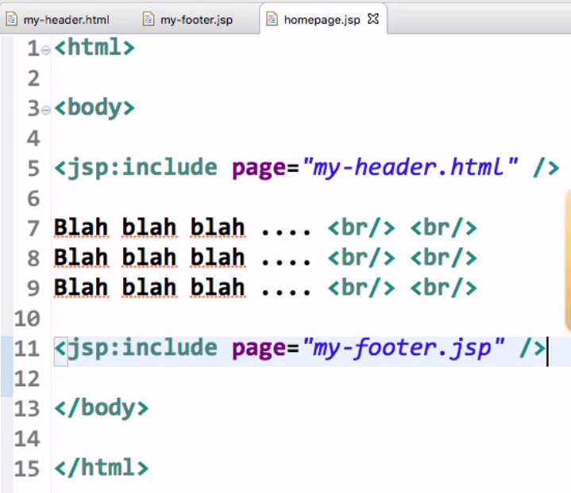

HTML Forms

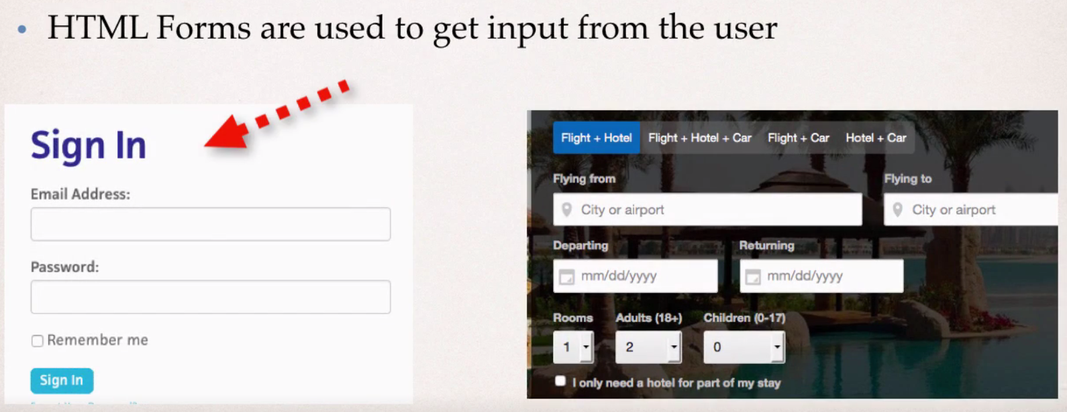
We will work on a sample example which will look something like this :
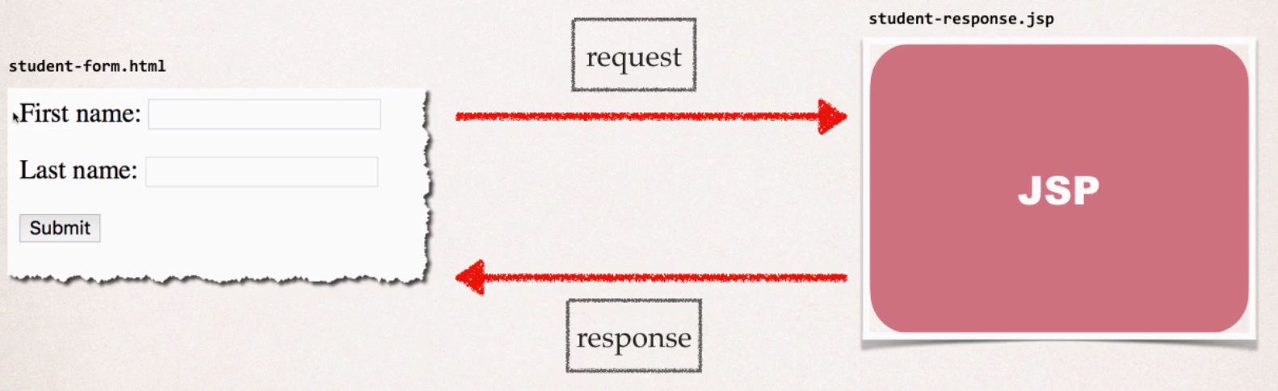

You start with <form> tag and you specify action, which tells HTML where to send the input data to.
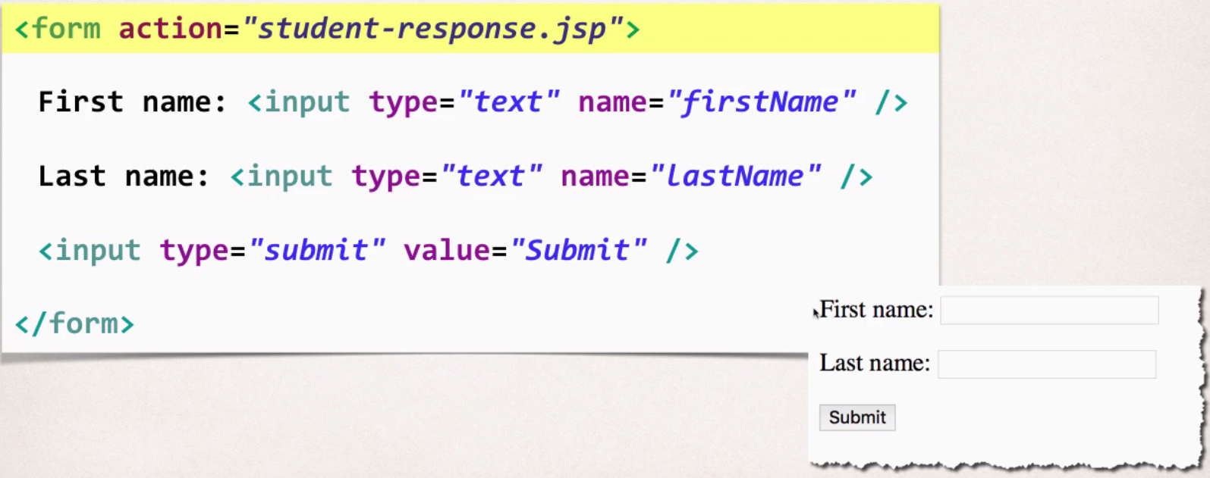

We are telling the system, where to send the form data, throught 'action' property.
For in the <input> tag, we are giving 'name' property. This is important and is uesd to refer to it on the server side**.

Reading Form data with JSP :

Whenever you read the form data with JSP, it is very important that we need to know the names of those HTML form fields.
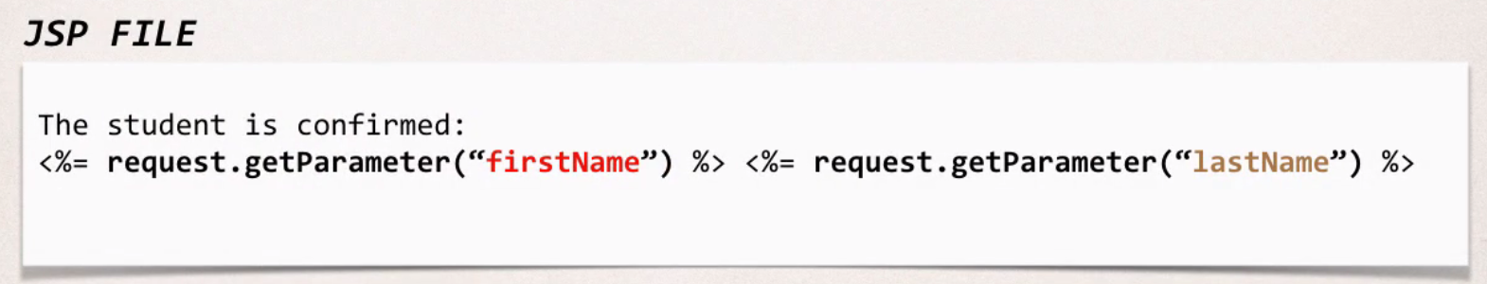
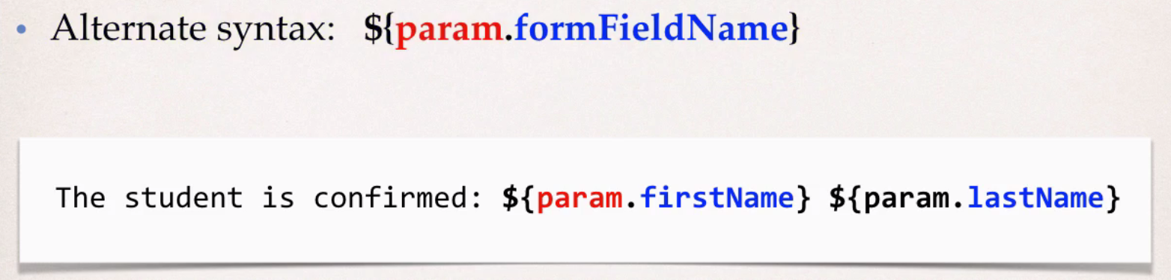

The alternate syntax is only used for displaying form data.

HTML Forms Drop-down lists <select> tag

Drop-down list looks something like this :
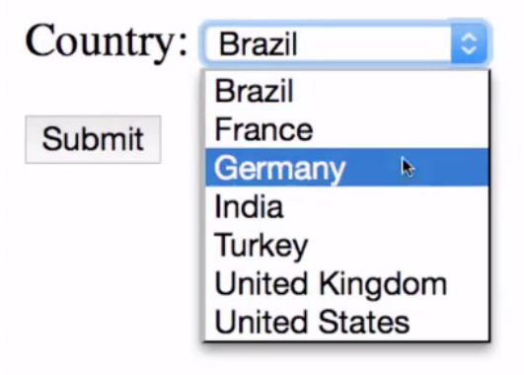
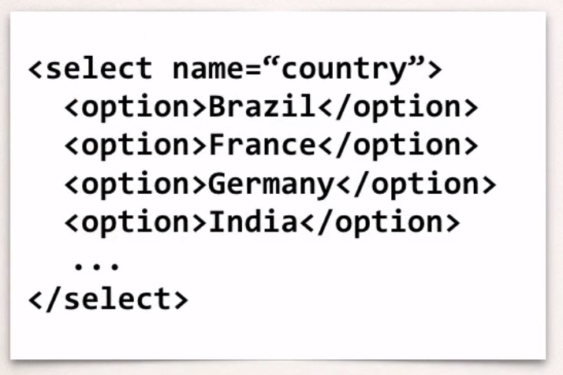
You can notice, we have given name for the select tag. That is the name used within the form to identify this select options. We will use this name within JSP to read the selection for this drop down list.

Reading the Drop-down data in JSP file :

It's the same syntax as earlier.
You can as well use : request.getParameter("country")

The student's country : <%= request.getParameter("country") %>

HTML Forms Radio Buttons

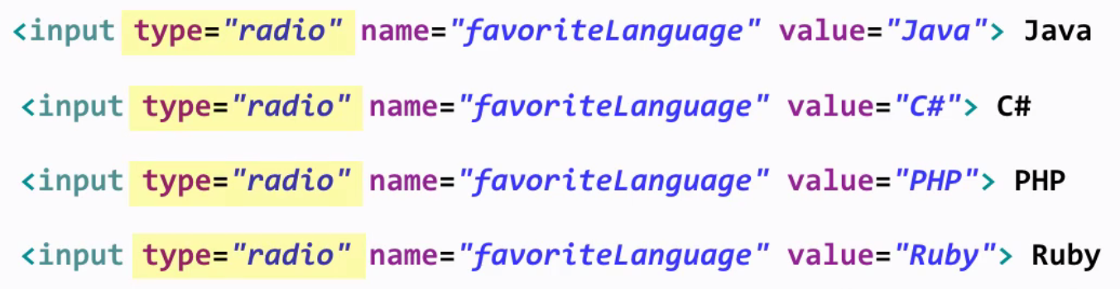
The key here is, type="radio" and name for the radiobutton, which we use within JSP to read the value.
This HTML will generate radio button which look like this :
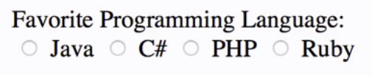

Reading Radio button data from JSP :

${param.favoriteLanguage}

You can also use alternate syntax : request.getParameter("favoriteLanguage")

HTML Forms Checkboxes

We generally use checkboxes for multiple selection of choices.
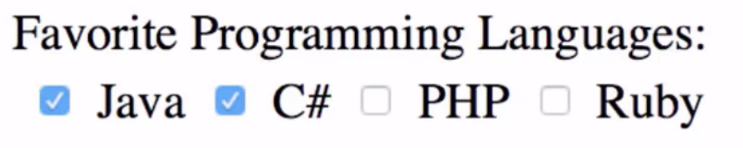

The HTML code is pretty similar to Radio button, except that we have changed the input type to 'checkbox'.
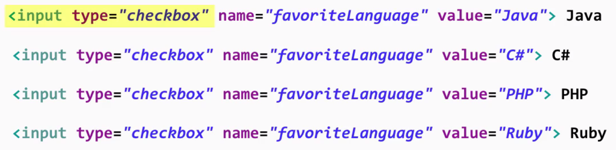

Reading Check box data in JSP file

Since the user can check multiple options, we need to use slightly different code in JSP. We need to get an array of values/options selected by user.

How to handle when user doesn't select a checkbox?
If the user doesn't select a checkbox, you will have a null pointer exception.
You can handle this by checking for null before displaying the data.
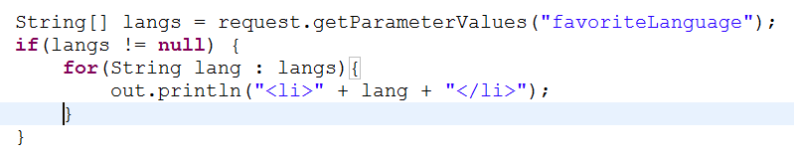

Session Tracking with JSP

Each browser has its own unique session object on the Tomcat server in memory and you can keep track of each user's individual actions.
Note:
- Session object is kept in memory and it's not stored in the database or file system.
- The session object is only in your server's memory.
- Each user has their own session ID. So, the Tomcat server will actually assign a session ID to the user. As a developer, we don't have to worry about generating session ID or passing session ID back and forth.



